SIT

Tested Date | Issue scenario | Response
Installation
22/08/16 | During APK installation, the screen showed record audio. Why?  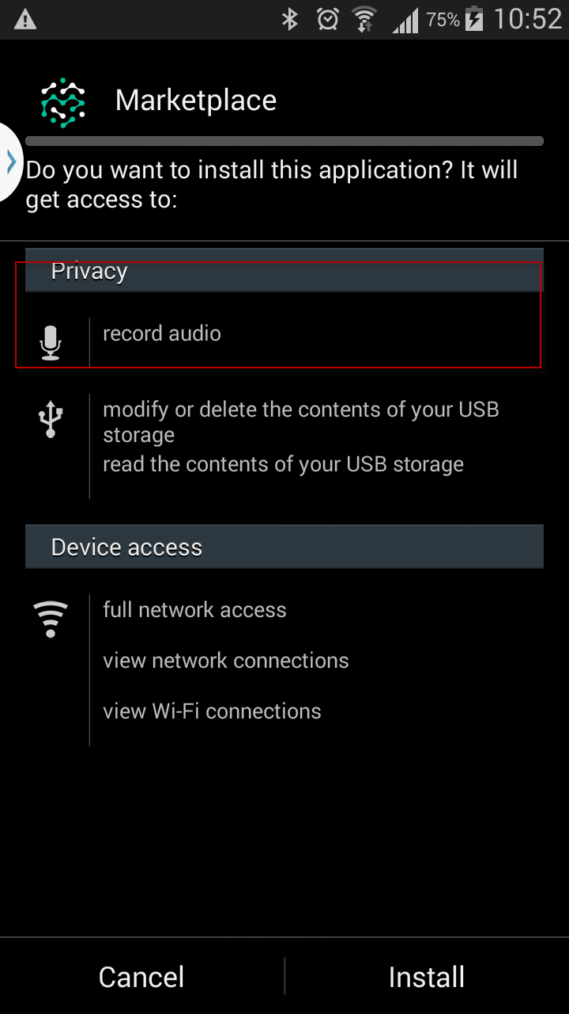 | This is part of cordova-plugin-media-capture  https://github.com/apache/cordova-plugin-media-capture  It is a plugin permission needed, in order to access the camera during photo taking. Third party requirement.  Solution: remove audio permission from files:  - Android.json  - AndroidManifest.XML  - Cordova-plugin-media-capture/plugin.xml  DONE
26/08/16 | Same issue as above | DONE
11/09/16 | Same issue as above  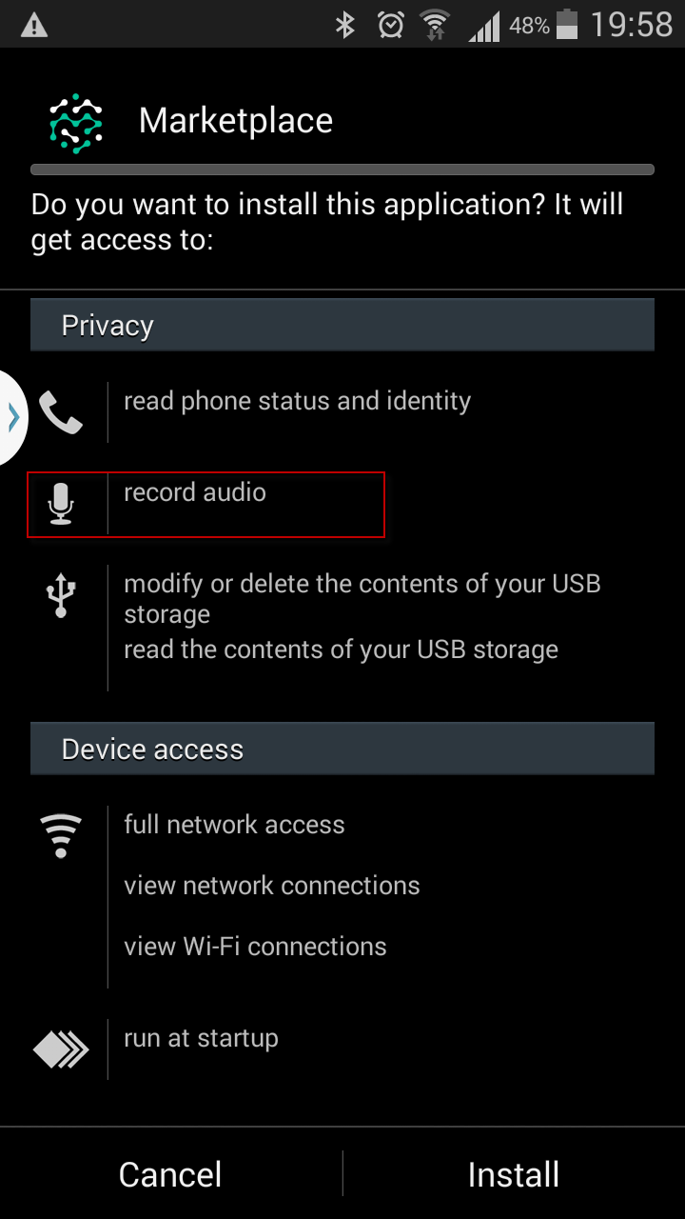 | DONE
26/08/16 | What is the current font type & its size applies to the app, title, content, etc. | OpenSans-Light.ttf  Default Font Size: 1em  DONE
11/09/16 | New request by Ms Sit to rename Acacia instead of Marketplace  - Sample screenshot; splash screen, login page, etc   & 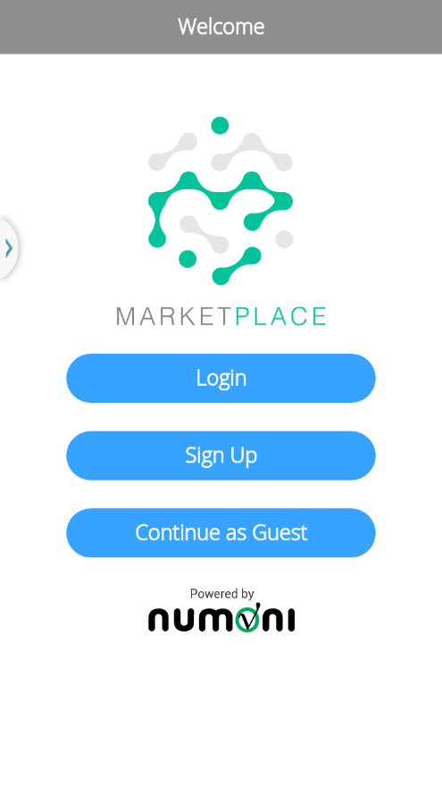 | DONE
 | Tab [App] > Splash Screen > Home > Header  - Please refer to the UI via google drive https://drive.google.com/drive/folders/0B9oOsWhCXi98LVNDT2UxQ3Q2Z0k  - Please confirm other screens the same header as stated in the google drive.  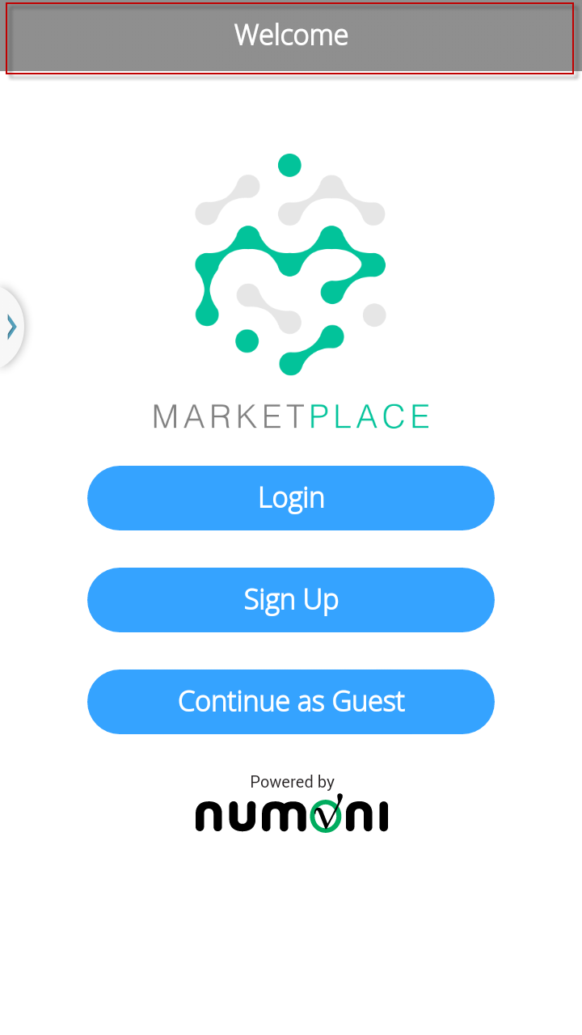  - If the title header has to be there, please ensure all the screens are consistency. Found my profile, chat feedback, search without the same header design. | Ok. Will switch profile, chat feedback, and search to have same header design.  DONE
Sign Up
11/09/16 | Sign Up > Profile Photo > Failed to Choose Photo From Gallery | DONE
26/08/16 | Sign-Up > Country field > Remove country default by putting ‘Please Select’.  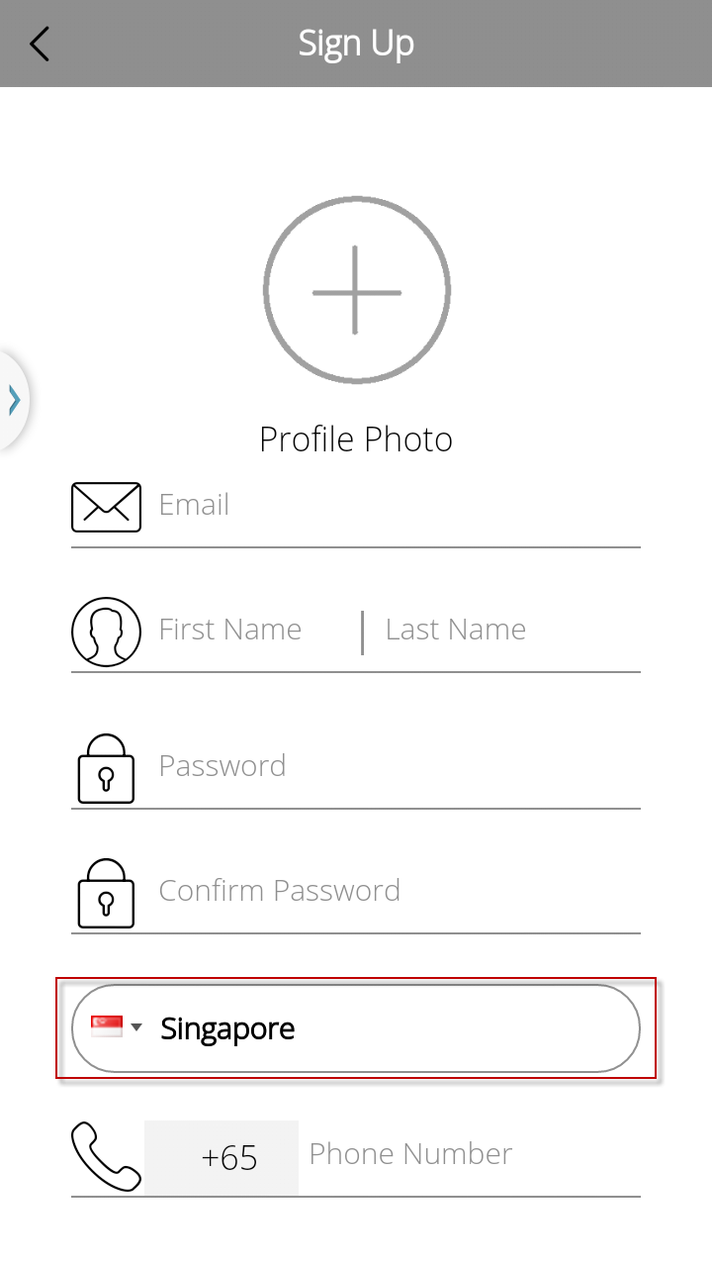 | DONE
11/09/16 | Sign Up > Underline pattern & colour inconsistency  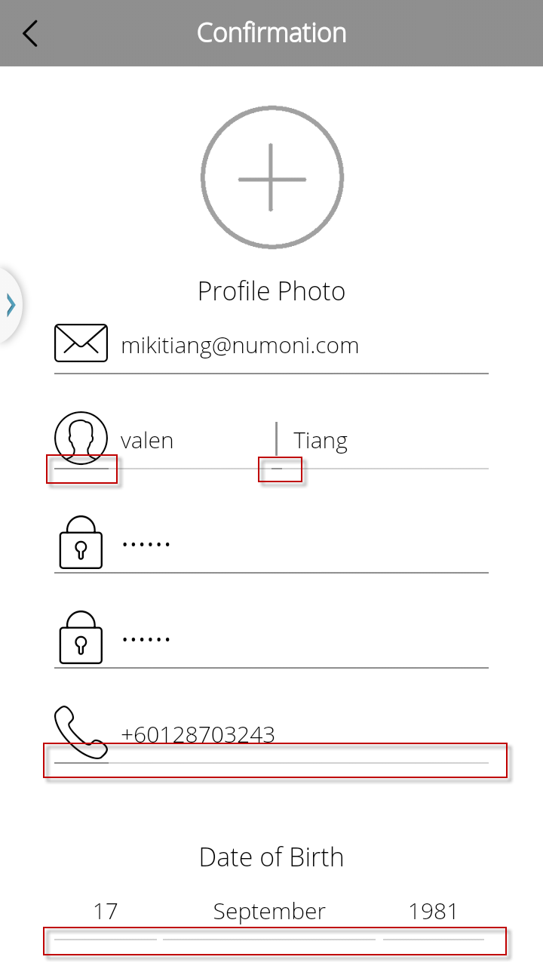 | DONE
 | Sign Up > Select Date of Birth > 13th May 1986 > Tab [OK] > Reselect Date of Birth >  - The calendar value remained as 17th Sep 1998 > It should be set to selected value 13th May 1998.  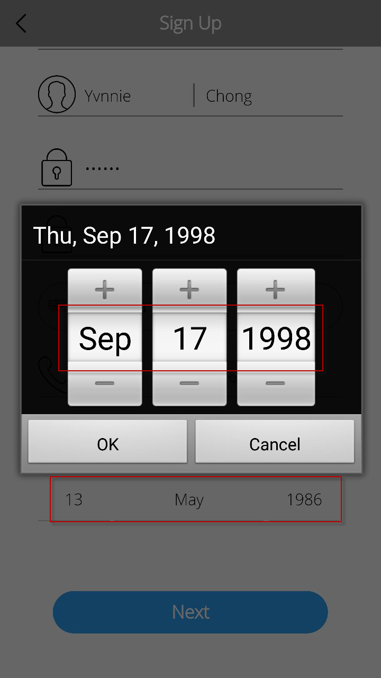 | DONE
 | Sign Up > fill in necessary fields > Submit > Successfully message prompted.  - The icon should be white, please refer to the UI via google drive  https://drive.google.com/drive/folders/0B9oOsWhCXi98LVNDT2UxQ3Q2Z0k  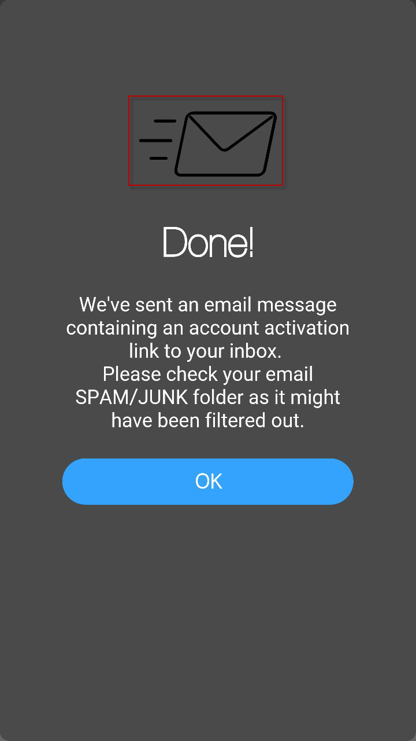 | DONE
Login
11/09/16 | Login > My Profile> Insufficient length to display DOB  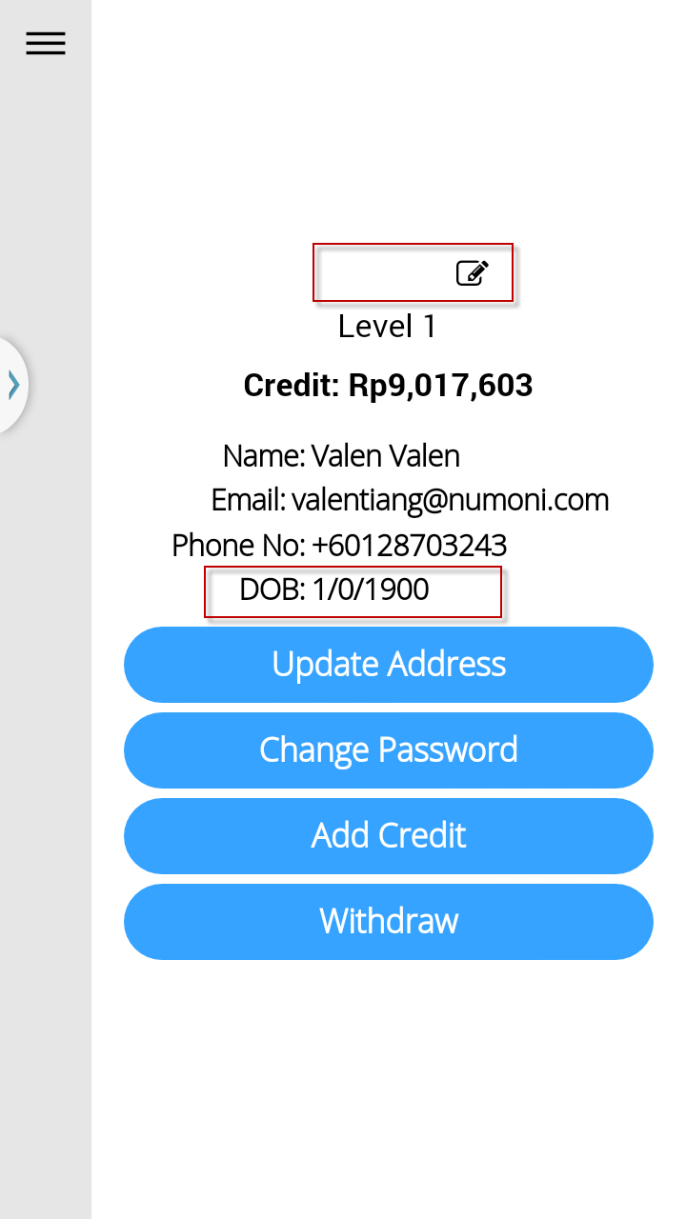 | Date of birth error value received from server side.  Date is minimum possible date set by server.  Profile photo is not showing, because of API URL issue.
 | Login > My Profile> Update Profile Photo > Failed to Choose Photo From Gallery | DONE
 | Login > My Profile> Update Profile Photo > Failed to Take Photo | Works on my side. Need to show me the exact case.
26/08/16 | Login > My Profile > Update Address  - Auto complete method applies to Country & City, suggest to make the same as State for consistency.  - Label of Please Input City is not consistency with the field: District/Town/City.  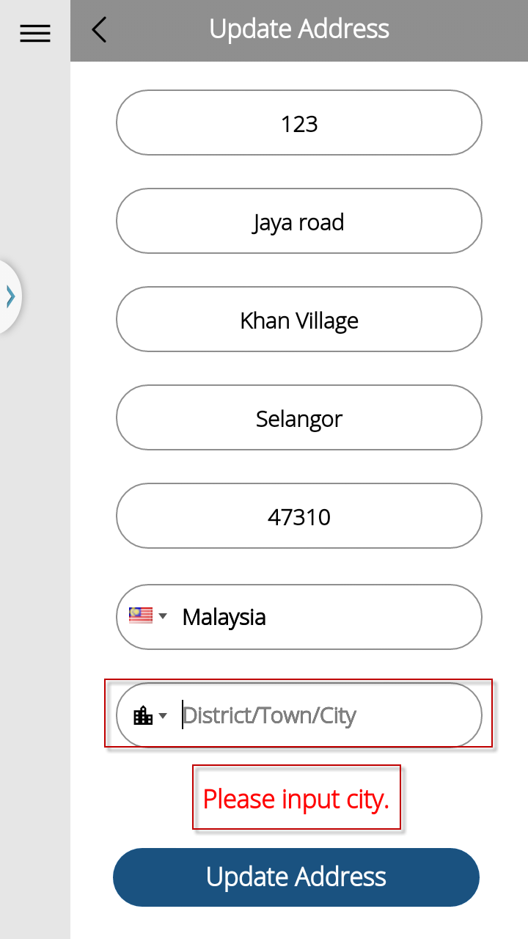  - Please re-arrange the field order as sequence diagram.  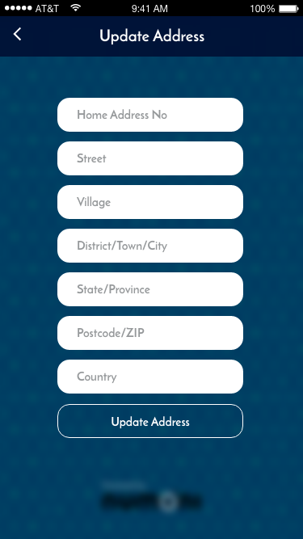 | DONE
 | Login > My Profile > Update Address > Tab [Update Address] > Update successful message prompted  > Back > Update Address again > Modifying House No to 20 but message prompted ‘Please Input City’.  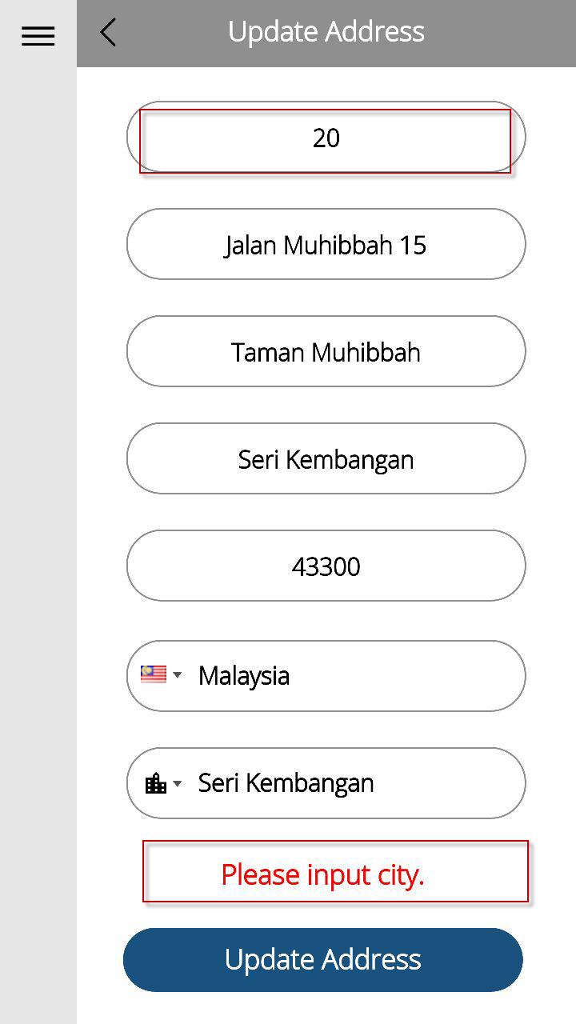 | DONE
 | Login > My Profile > Update Address > Tab [Update Address] > Update successful message prompted > Back > Update Address again > Modifying Post Code to ‘47312’ > Tab [Update Address] but failed to update.  - Application allows update address once, but failed on the second time. Please confirm the API - UpdateAddress API | It appears OK on my end.  Managed to update address several times.  Need more data from testing. Might be API issue.
 | Login > My Profile > The value displayed differed from Sign-Up  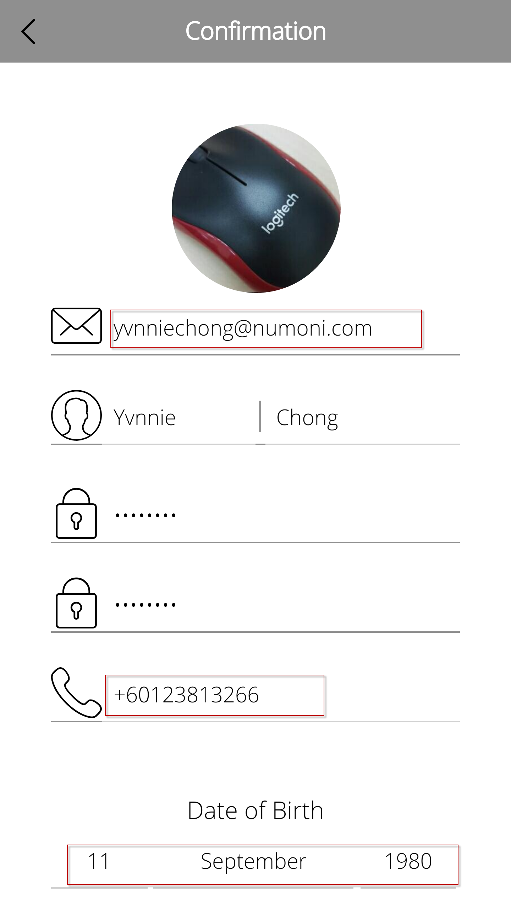 ≠ 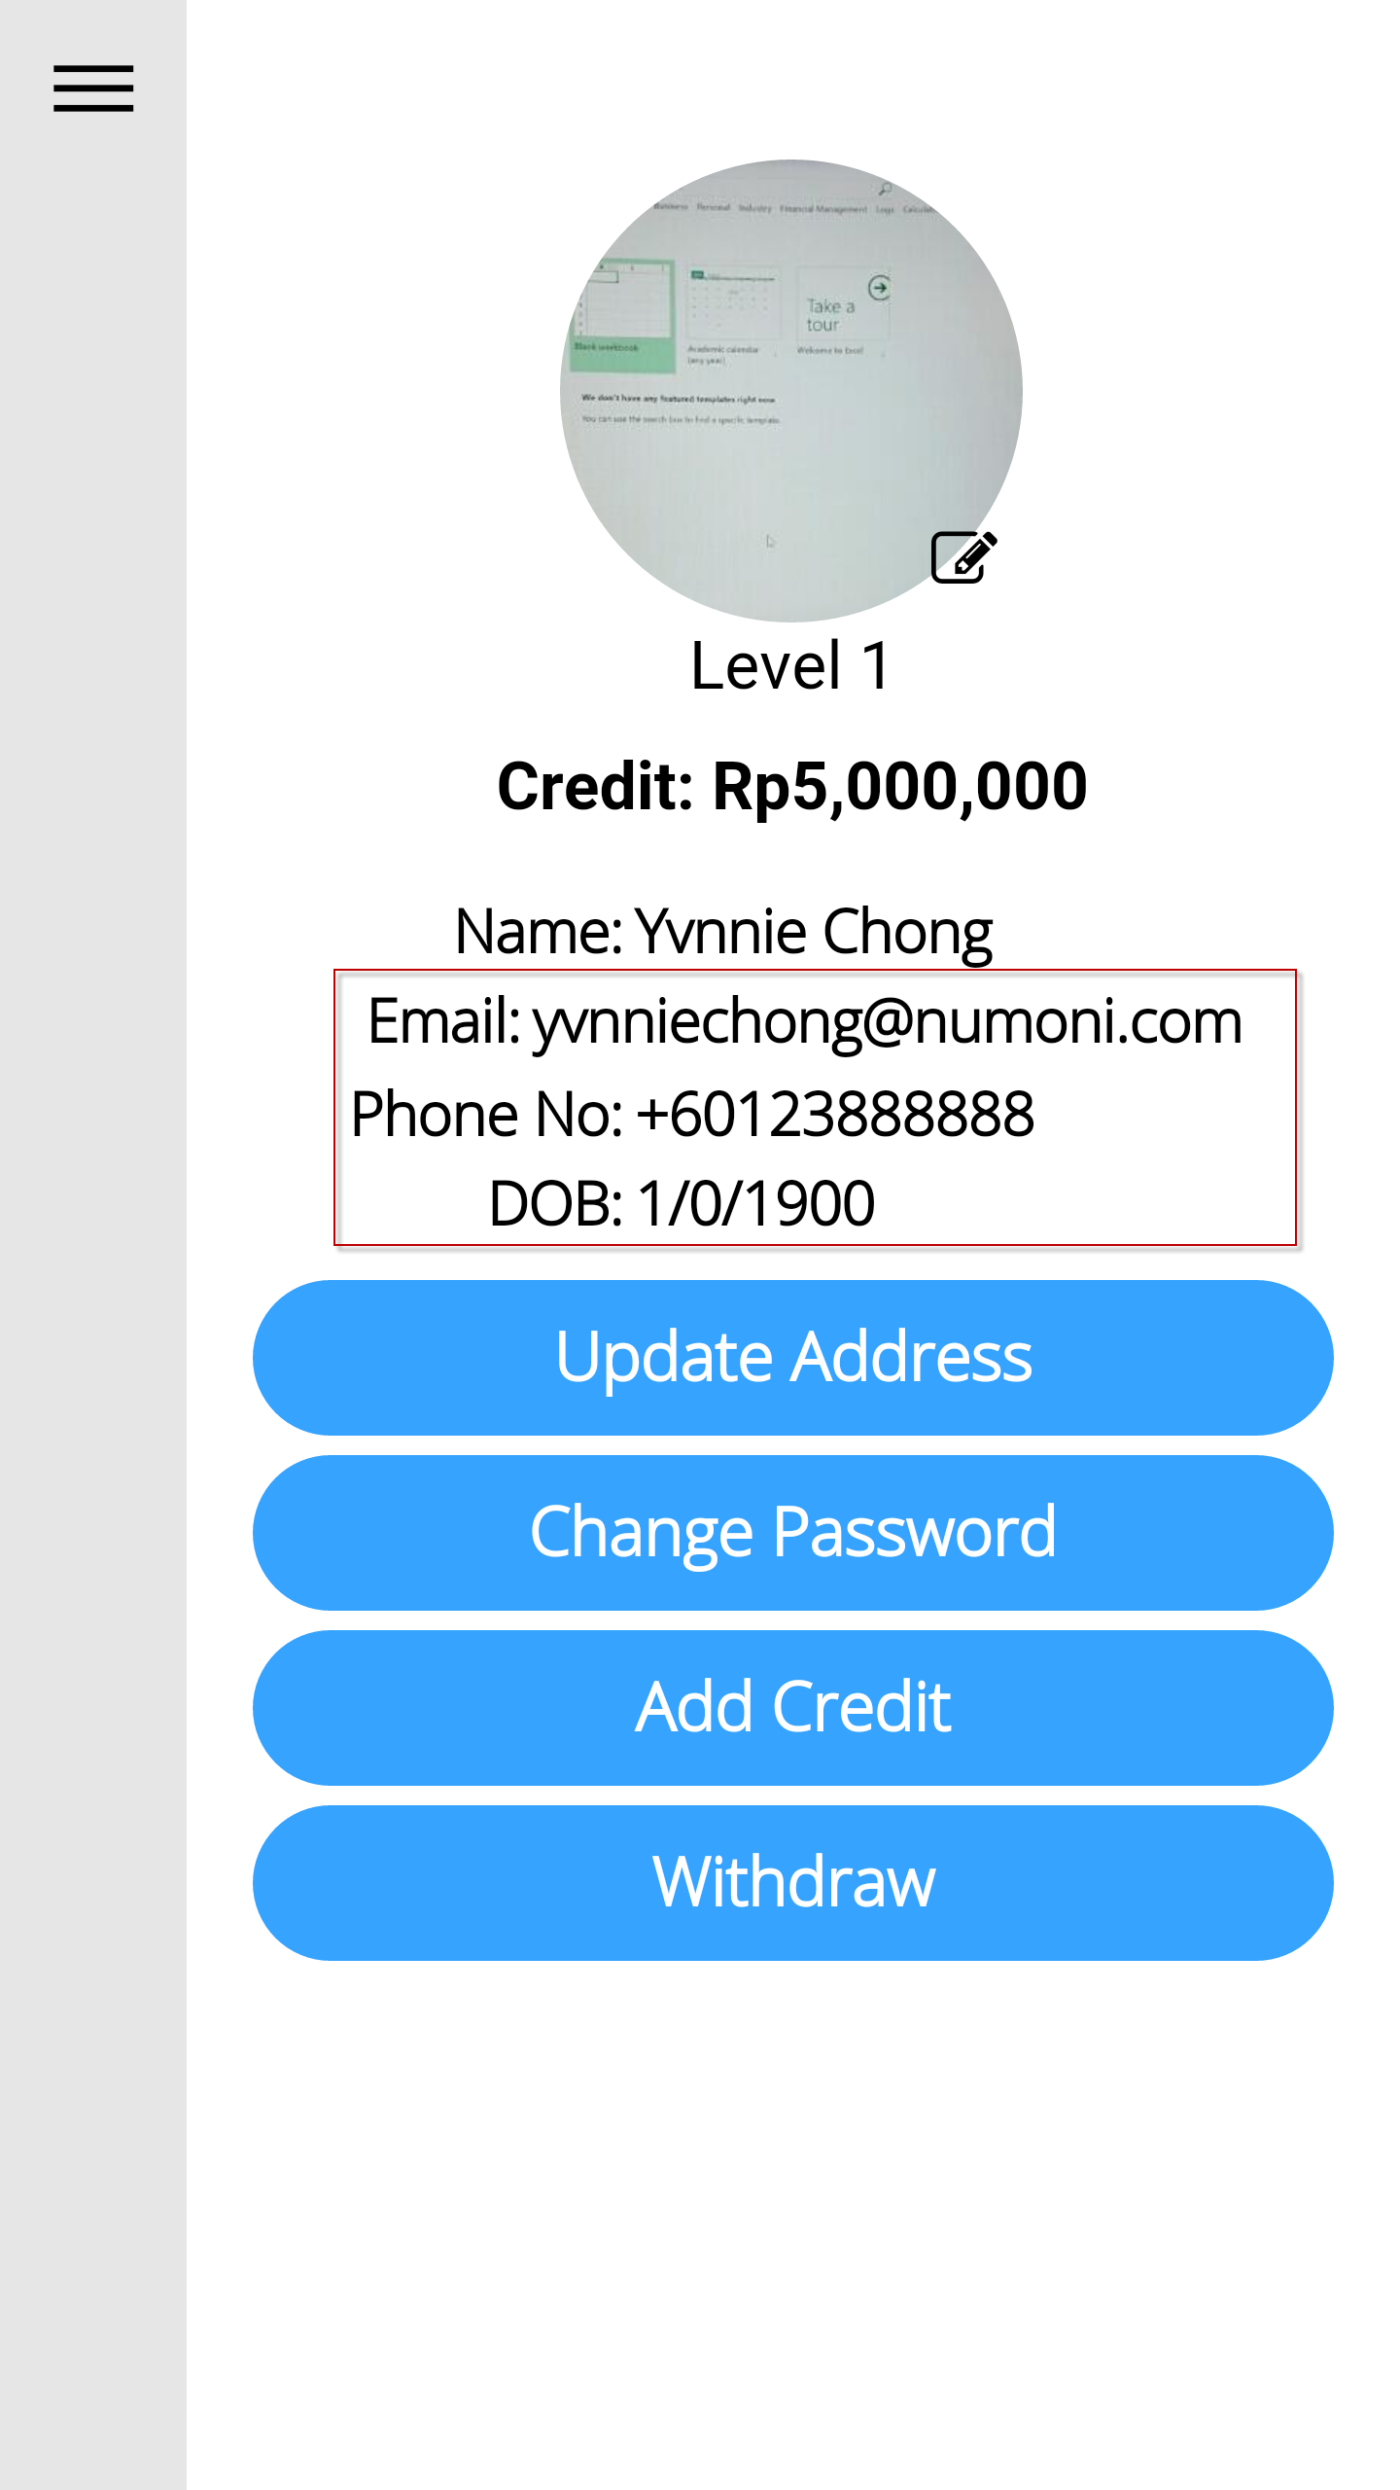 | Need to check with API. Returned values are values taken directly from server.
 | Login > My Profile > Change Password  - Update Password button being truncated.  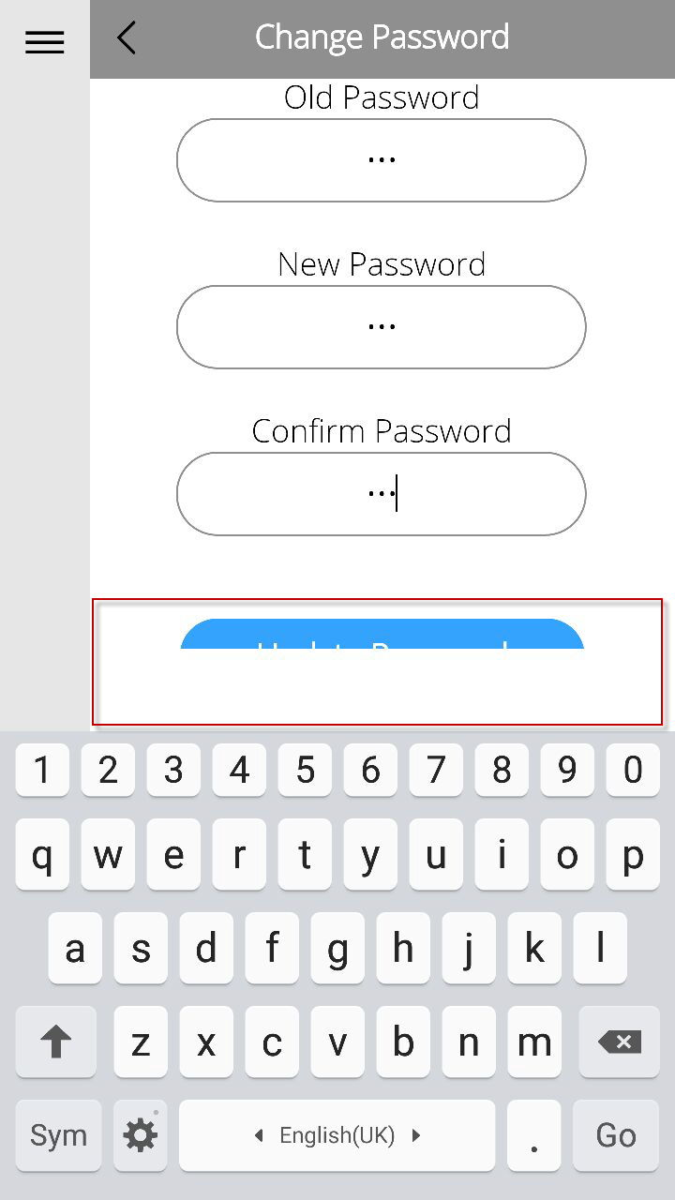 | DONE  I redid the layout for HTML scrolling. However, this may be also caused by graphical glitch within web browser, and is hard to replicate.
 | Login > My Profile > Add Credit > Fill in Rp70,000 > Add Credit Summary > Select Payment Type > Credit Card > Failed to redirect to mock-up payment gateway > Add credit successfully.  - The screen is not the same as UI  - The payment gateway redirect to a website news.  - No integration to mock up payment gateway.  - User Tab [Pay] without Select Payment Method, should prompt an alert message.  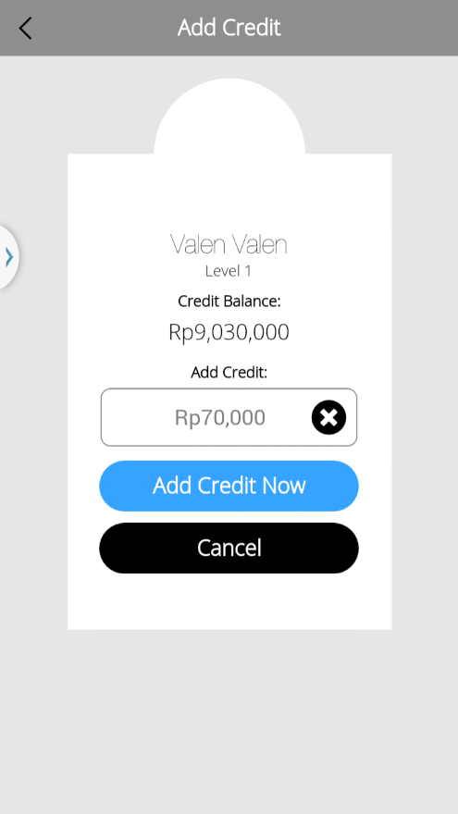 > 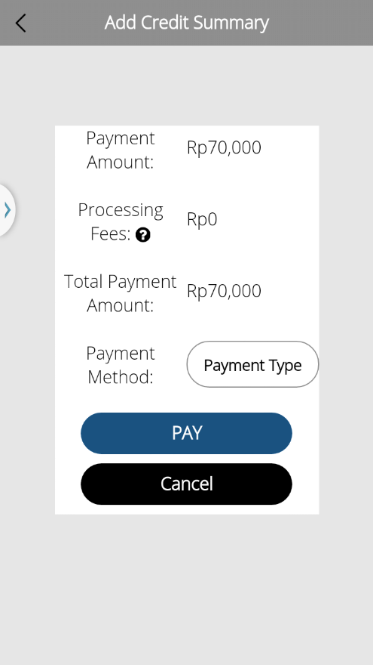 > 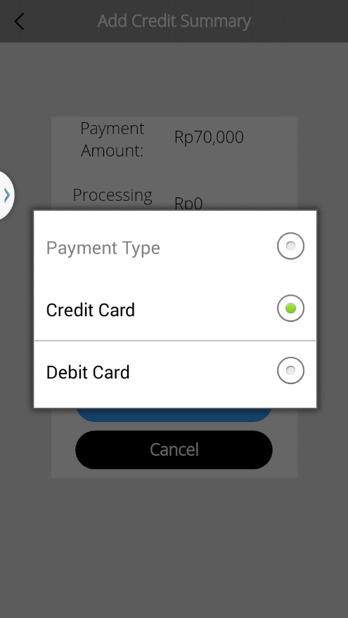 > 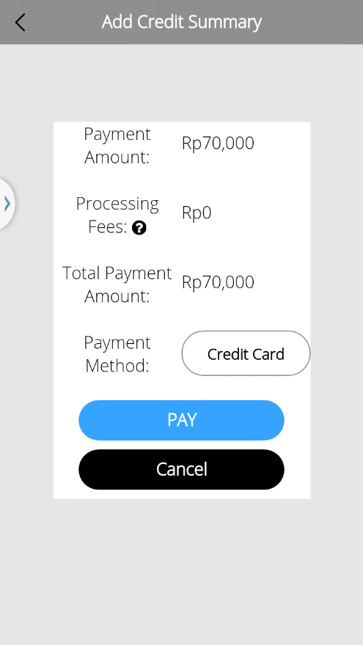 > 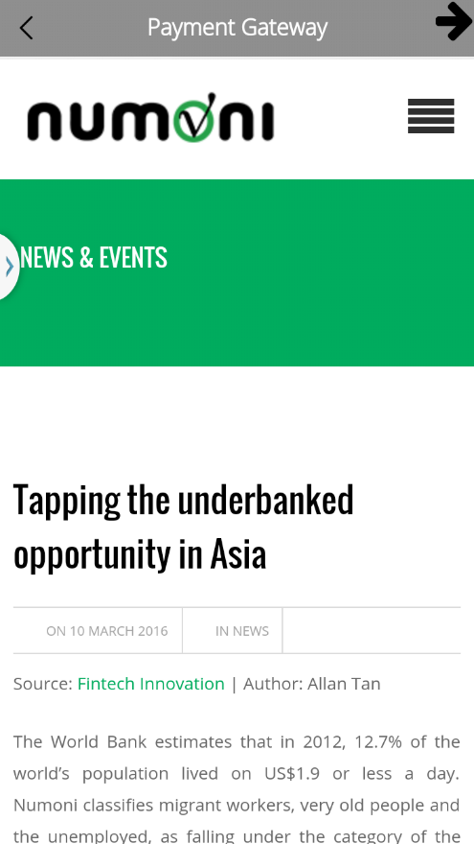 > 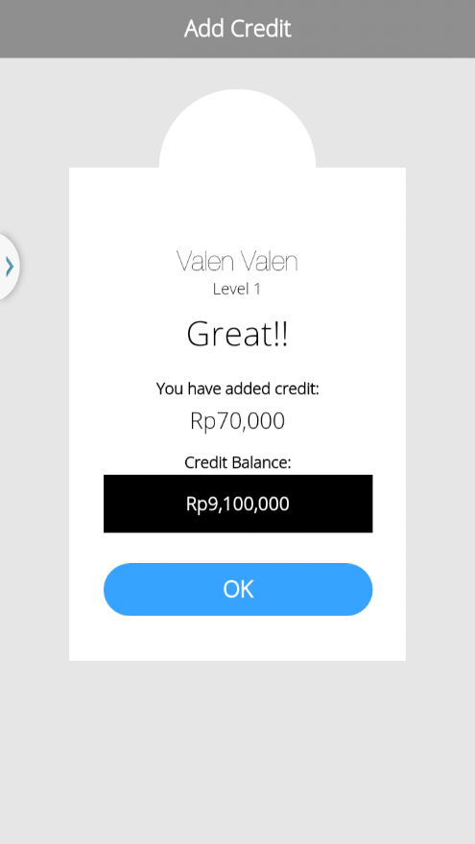 | I have not received this specification till now,  Nor have I received the API specification from Henny. as of 12 September 2016.  I will try to finish based on this specification with the API, when it comes.
 | Login > My Loans Portfolio  - UI differed from google drive, please refer to URL https://drive.google.com/drive/folders/0B9oOsWhCXi98b1FxVVB5S0lwRjg  - Please confirm other screens too  - Selected label being truncated.  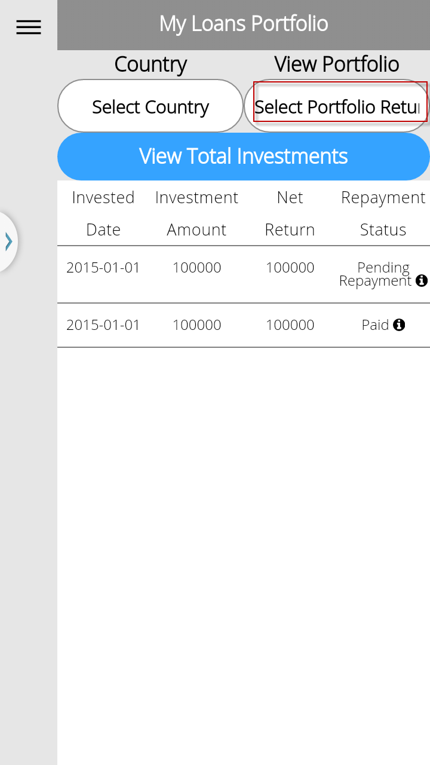 ≠ 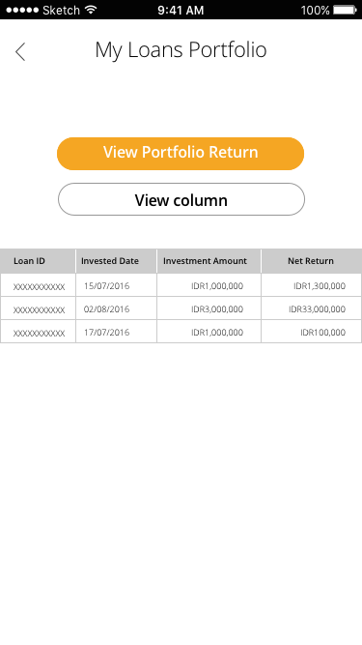 | I have not received this specification till now,  Nor have I received the API specification from Henny. as of 12 September 2016.  I will try to finish based on this specification with the API, when it comes.
 | Login > Transaction History  - UI differed from google drive, please refer to URL https://drive.google.com/drive/folders/0B9oOsWhCXi98b1FxVVB5S0lwRjg  - Please confirm other screens too  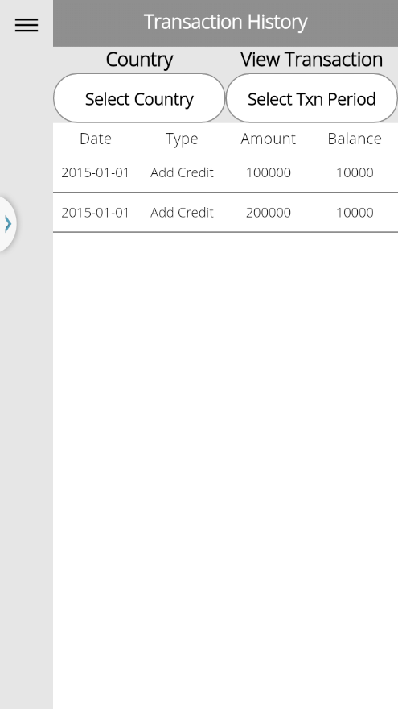 ≠ 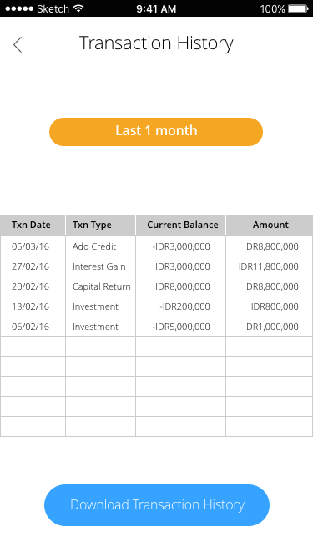 | I have not received this specification till now,  Nor have I received the API specification from Henny. as of 12 September 2016.  I will try to finish based on this specification with the API, when it comes.
 | Login > Contact Us / FAQ  - UI differed from google drive, please refer to URL https://drive.google.com/drive/folders/0B9oOsWhCXi98b1FxVVB5S0lwRjg  - It may easy to refer FAQ when Investor accesses Contact Us, instead of Back/Undo; all in one page but different link.  - FAQ message layout & content differed from design. Please refer to google drive above.  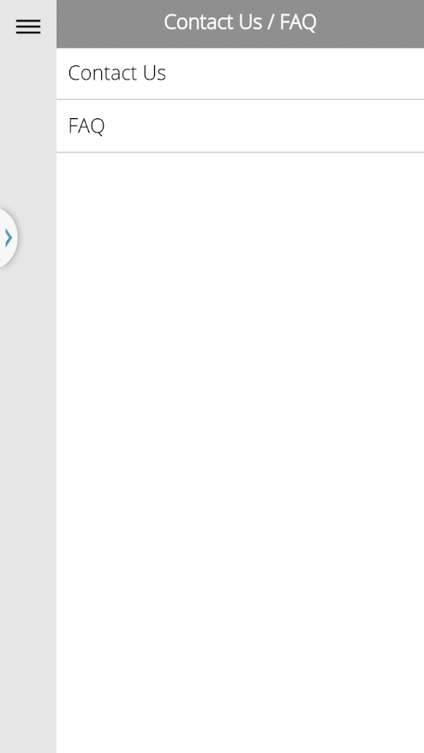 > 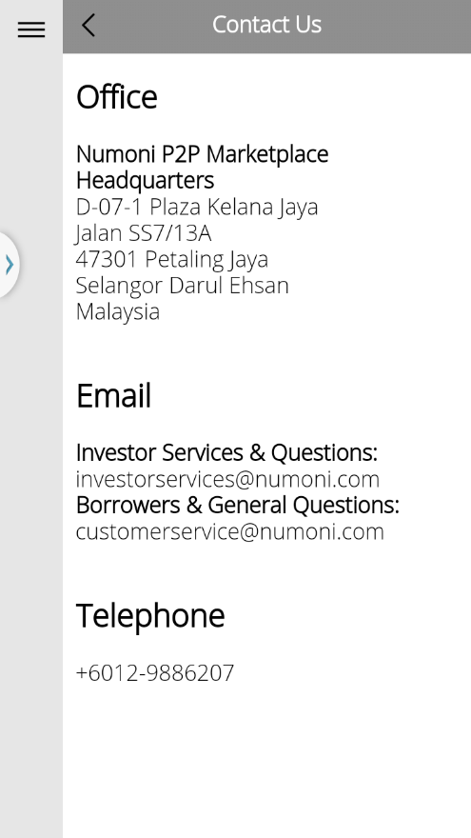> 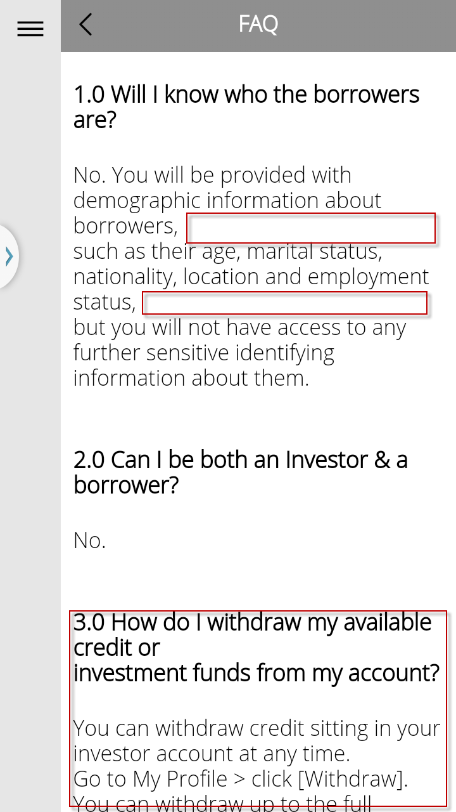≠ 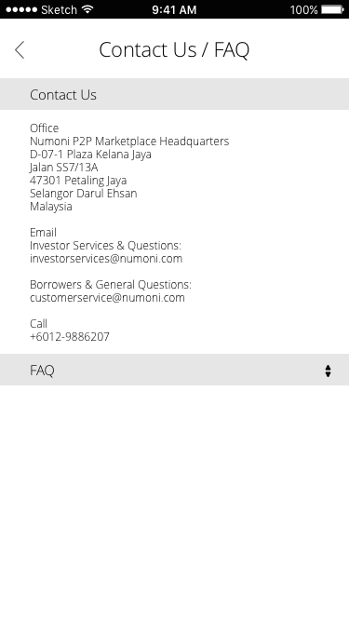 | I did not receive this specification till right now, as of 12 September 2016.  I will try to finish based on this specification.  DONE
Searching Criteria
11/09/16 | Searching of Loan Amount sometimes displayed Rp100, sometimes $100  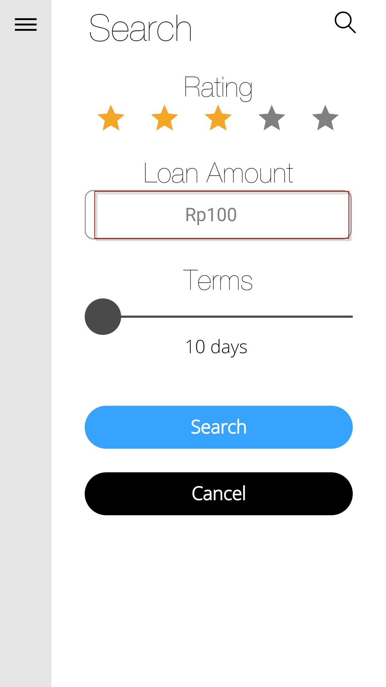≠ 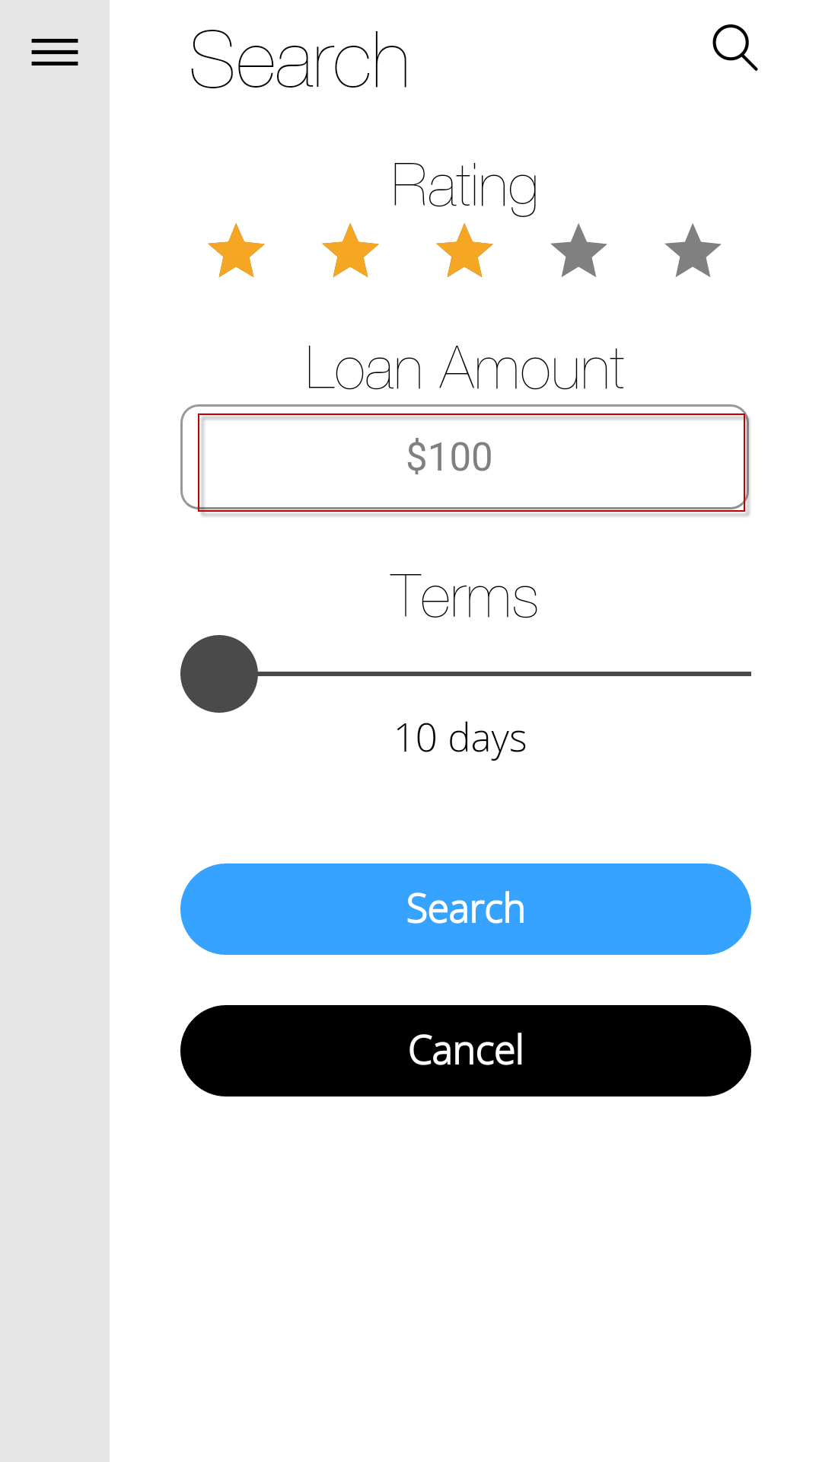  Loan Amount allow alphabet??  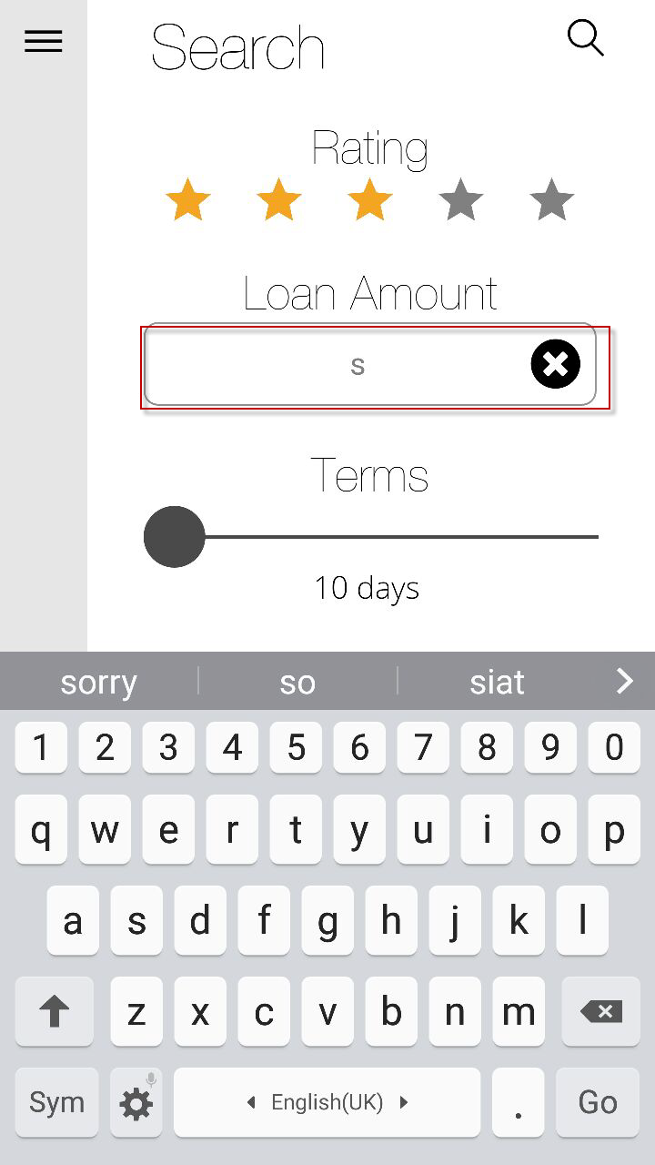 | Loan Amount Does not Allow Alphabet. It is programmed to reject alphabets, and reset the input field if any characters other than numbers are entered.  When user is not logged in, default currency is USD. How should we resolve different currencies involved?  Henny: Country API suggested, where we search based on countries. Add additional field for countries.  During login as registered USER /GUEST, return list of available countries user can search.
 | Search > Default page of search displayed > Input $10,000 but Loan Amount value displayed $100,010,000.  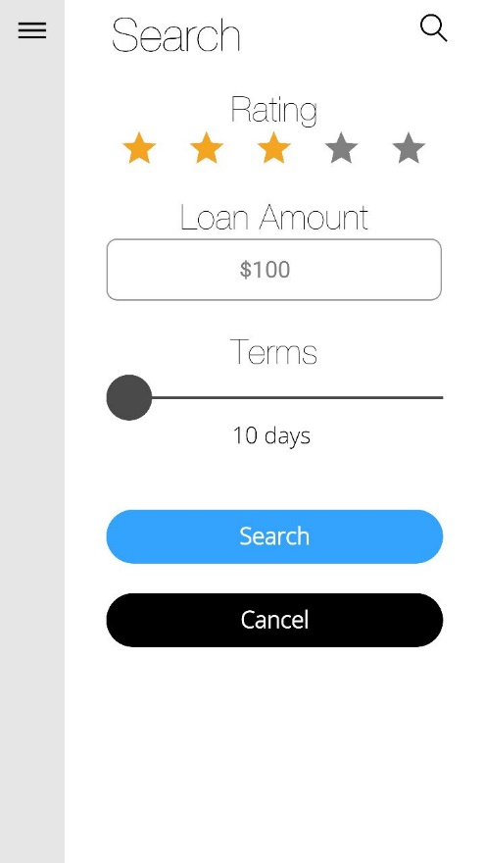 > 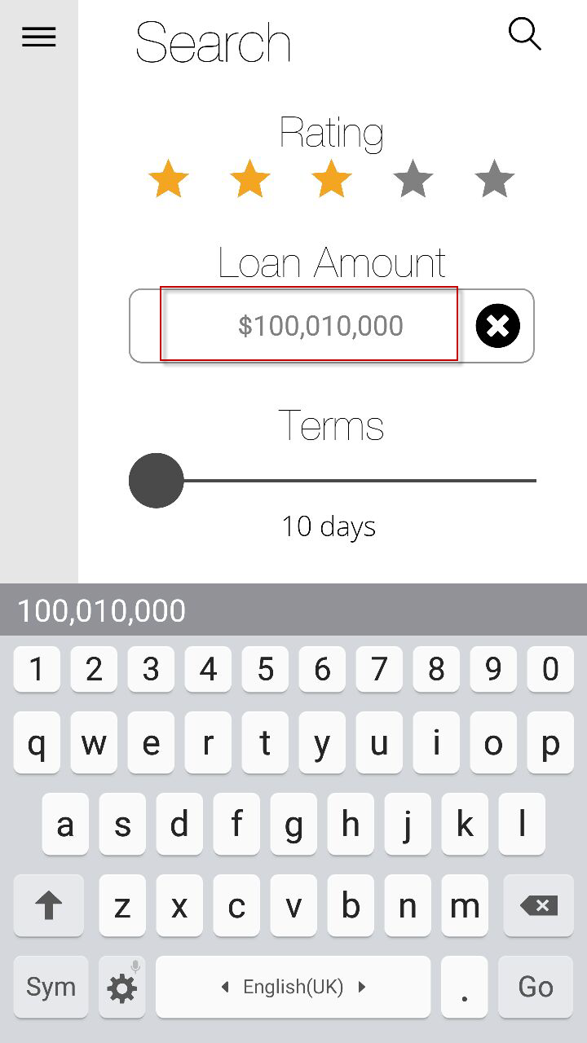  Search > Input $3,000 but Loan Amount value displayed $33,000.  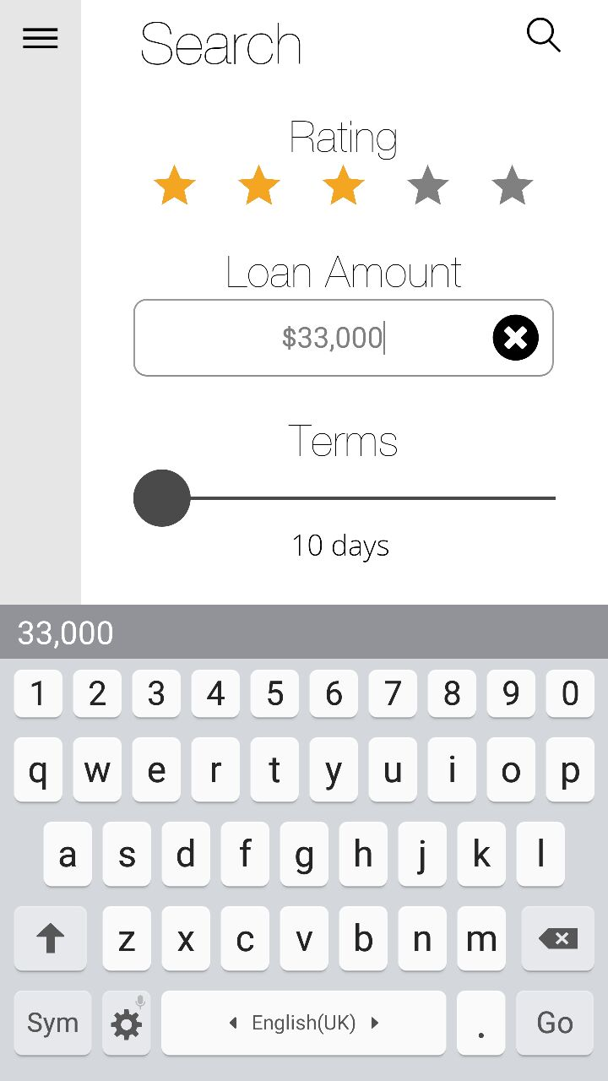 | I have not been able to replicate this on my phones (Samsung Mini J, Galaxy Note). However, some keyboards that have autocomplete on them do affect input, despite disabling such function on cordova side. Need further testing.
 | Error as below prompted randomly.  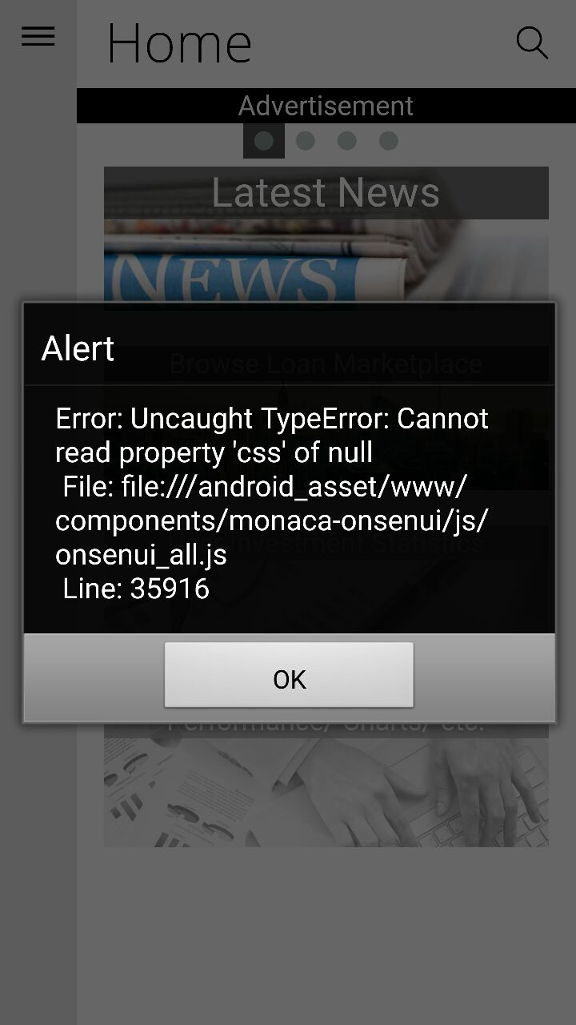 | DONE

